Hack 1: SoilGuru Tutorial

Goal: Measure soil humidity and plots them in a graph.

Set up: A simple sensor made of nails which are connected to the Arduino. The Arduino than is connected to the computer which runs a Python script. The script reads them and outputs the measurements in a graph.

Tutorial:

Hardware:

Soil humidity sensor:

Cut 2 pieces of wire, each 2’ long, and strip 1/2“ off the ends.

Wrap 1 end of each wire around the head of each nail.

Cover the wire-nail connection with a generous amount of solder.

Connect the sensor indicated in the picture below:

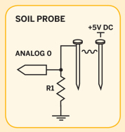

After connecting the sensor to the Arduino connect the Arduino to the computer via an USB cable.

Software:

Arduino: when the hardware is connected properly. Upload the Arduino (Hyperlink) sketch.

Computer: open Python and install pyserial, the program which communicates with the Arduino.

….